Practical Documentation
~By:- Dev Bhatia

Practical Number :
20

Code
Code screenshot is below:
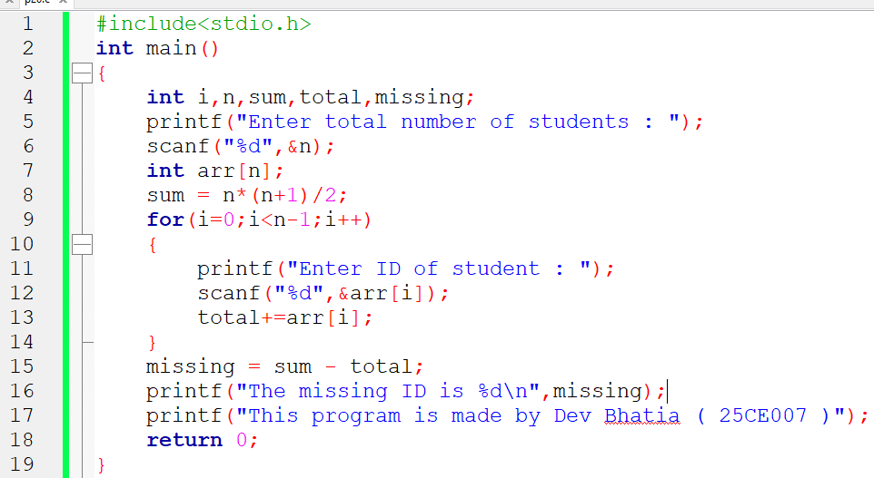

Output
Output screenshot is below:
